**Lab Report #05**

**Experiment Name #** First Come First Serve(FCFS) Scheduling Algorithm.

**Aim and Objective:**

The purpose of the experiment is to learn First Come First Serve(FCFS) scheduling algorithm and execute a code by using this.

* To learn FCFS scheduling algorithm.
* To implement FCFS using C.

**Code:**

#include<stdio.h>

main()

{

int n,a[10],b[10],t[10],w[10],g[10],i,m;

float tat=0,awt=0;

for(i=0;i<10;i++)

{

a[i]=0; b[i]=0; w[i]=0; g[i]=0;

}

printf("enter the number of process");

scanf("%d",&n);

printf("enter the burst times");

for(i=0;i<n;i++)

scanf("%d",&b[i]);

printf("\nenter the arrival times");

for(i=0;i<n;i++)

scanf("%d",&a[i]);

g[0]=0;

for(i=0;i<10;i++)

g[i+1]=g[i]+b[i];

for(i=0;i<n;i++)

{

w[i]=g[i]-a[i];

t[i]=g[i+1]-a[i];

awt=awt+w[i];

tat=tat+t[i];

}

awt =awt/n;

tat=tat/n;

printf("\n\tprocess\twaiting time\tturn around time\n");

for(i=0;i<n;i++)

{

printf("\tp%d\t\t%d\t\t%d\n",i,w[i],t[i]);

}

printf("Average waiting time: %f\n",awt);

printf("Average turn around time: %f\n",tat);

}

**Output:**

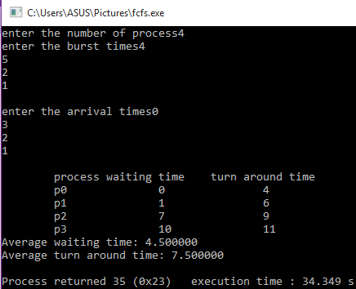

**Conclusion:**

By following these steps one can perform first come first serve using c. In this algorithm the process which comes first that has to do the job first. It is quite important CPU scheduling in operation system.